BAK UP CIC END OF YEAR REPORT DECEMBER 2021
We started the year some how not knowing where the whole travel of direction will lead us due to the pandemic and political direction. During the year we were told by government sources how the pandemic has and continue to affect the lives of many families, those on low income and the over 65+. According to government own sources around 5.5 million families have been affected, 1.5 million household will see their bills gone up already. The harder you work the better you will be they say but that is not surely the case among real people in our communities.
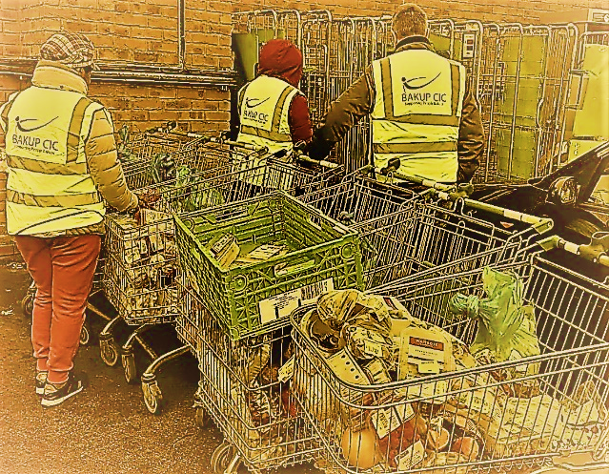
The government intention to level up our communities hasn’t happened and while we thought things were settling down Omicron (another new variant) just showed up. Again, many small businesses are not sure what to do. At the heart of all these uncertainties the jobs and lives of ordinary men, women and families across our country are been impacted and our community is no exception. Many are still furlough, others have lost their jobs, some are struggling to heat their home and eat but the good news is that BAK UP CIC has gone all the way to support 10000 beneficiaries for the past 18 months alone and this in part has been made possible due to your financial support. We have and continue to provide good quality food boxes to struggling families, those on low income, and older adults in Rushden, Higham Ferrers, Raunds, Oundle and Northampton. Also, families in Bedford and Milton Keynes respectively. Thanks to you, we have been able to donate food boxes to other charities including Rush2the Den, Raunds Food Bank, and Thrapston food bank to support them provide food for the vulnerable and prepare good meal for those who rely on their services each week.
Chris sadly lost her daughter who left behind two lovely children but thanks to donors like you we can make sure Chris and his grandchildren have the Christmas they deserve.
Again, with your help we can continue to provide support for Nicky, a nurse who was referred to us by a concern individual about how she was struggling to heat her home and feed her three daughters. The impact of our ongoing support has led to many more success stories like Chris and Nicky scattered across many homes in our community.
Sadly, more families will be struggling this winter.
Your gift at Christmas will help us get food to these families and help them back up.
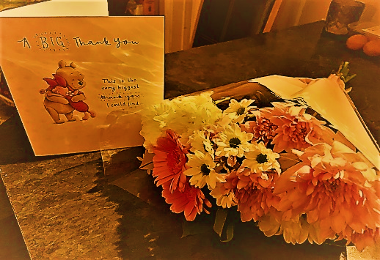
From the BAK UP CIC team we want to say a big thank you for support and we wish you a very
Merry Christmas !
Your sincerely,
Prince Caesar

Founder and Director
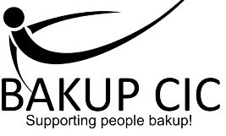
Website: https://www.bakupservices.co.uk
Facebook: https://WWW. Facebook.com/BAKUP CIC

